(Approx. 3,011 words)

Microsoft Office 2007 Review
by Lynn Page, Editor, Crystal River User Group, Florida
www.crug.org
newsletter(at)crug.com

Obtained from APCUG with the author's permission for publication by APCUG member groups.

Microsoft’s Office 2007 is the perfect suite of applications and is suited to all types of users. Office will aid you in being more productive and allow your documents, spreadsheets and presentations to be professional and attractive. Different versions of Office 2007 include different applications, from the Basic version with Word, Excel, and Outlook, to an Enterprise version including everything. This variety of suites may seem overkill but it provides an Office suite in complexity and price range for anyone. I have been using Microsoft Office Professional since Office 95. The only version that I skipped was Office 2000 and I still used it on the CRUG computers. After finishing my last Word 2003 class in late November I upgraded to Office 2007 Professional. It includes Word, Excel, PowerPoint, Outlook, Access and Publisher.

I personally use Word and Outlook extensively and also use Excel and Access for particular tasks and PowerPoint for meeting presentations and classes. Because of my love of Microsoft Word I don’t often use Publisher. I tend to try to use Word, if at all possible, but find myself occasionally needing to use Publisher for those tasks that are very graphically oriented.

I will be reviewing Office 2007 in steps through CRUG’s monthly newsletters. This month I discuss the Office suite in general and Outlook 2007. In following months I will take a deeper look at Word, Excel, PowerPoint and Access. In November we published a review of Publisher 2007 so I will not discuss that application.

The Ribbon

The first thing you notice with Office 2007 is the completely new user interface. The new Ribbon interface is really attractive and provides a totally new look. After the initial shock and adjustment period I found the Ribbon quite intuitive. It gives past users the chance to improve productivity but will really benefit new users. No more searching through layers of drop down menus to find commands.

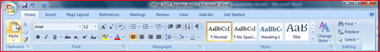

The new Ribbon interface which replaced the drop down menus and toolbars in Word, Excel, PowerPoint and Access can seem confusing at first, as anything new can be. But the Ribbon provides quick access to program features. It organizes commands into logical groups on tabs relating to a type of activity. Some tabs appear only when needed like the Picture Tools tab, shown when a picture is selected. When a picture is selected a new tab appears at the far right with Picture Tools above the line of tabs.

When a tab is selected the Ribbon becomes a graphical presentation of the program commands in that group. This means that commands are readily available and noticeable. It is easy to see things you may never have know existed or just thought were too much trouble to find.

The main Outlook application window does not use the new Ribbon interface. However, the Ribbon is used in Outlook’s content creation windows. I wish that Microsoft had carried the Ribbon interface through all Office applications.


The biggest problem I had with the Ribbon interface was finding the old File drop down menu commands. The new Office Button replaces the File drop down menu and Options dialog. Clicking the button in at the top left of the application window opens a new drop down menu. From the menu you can create a new document, open an existing document and save or print the current document. It also provides a list of recently accessed documents. The Options dialog box is accessed from the menu.

File Formats

The default file formats for Word, Excel, and PowerPoint are XML formats but it is easy to select the option to maintain compatibility with Office 2003 applications. The new file name extensions add an "x" or an "m" to the file name extensions used in earlier versions of Office. The "x" signifies an XML file with no macros, and the "m" signifies an XML file containing macros.

The XML file formats reduce file size, offer ease of information transfer between applications and automate formatting changes across libraries of documents. For individual users like me the compatibility with Office 2003, on my desktop computer, can outweigh the loss of some new features. I select the file format depending on how and where I will use a particular file. And I have downloaded and installed the file convertors on my Office 2003 computer so I can open Office 2007 files.

Office XML Formats automatically compress files using zip compression to store documents. To open a file, it is automatically unzipped. When you save a file, it is automatically zipped again. XML files are modular with different data components separate allowing files to be opened even if a component within the file is corrupted. This can be a true life saver when working with a complex document. Another advantage of Office 2007 new formats is protecting privacy by controlling personal information. Just Remove hidden data and personal information before sharing a document.

Save as PDF

Now you can save as a PDF or XPS file right from most 2007 Office applications. You do have to download and install the add-in. This little bit of time and effort is well spent. Although I was surprised that it was not an integral part of Office 2007.

I use PDF for the email newsletters and sharing many files. So the ability to convert and save my Office documents to PDF without an additional application was one of the most important features in Office 2007 for me. I like to use PDF because it ensures the file remains as I created it when viewed online or printed. Another benefit is that the file and data in it cannot be easily changed.

You can save your files in PDF but still need a PDF reader installed on your computer to view it. And after you save a file as PDF, you cannot use Office applications to make changes directly to the PDF file. Unless you have a PDF application on your computer you will need to make changes to the original file in the Office 2007 application program where you created it and save the file again as PDF.

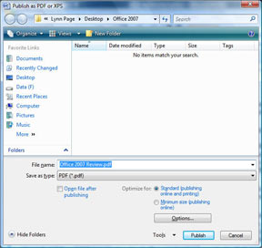
To save a file created in Word, Excel, PowerPoint, Outlook, and Access, click the Microsoft Office Button, select Save As, and then click PDF or XPS. Type a name for the file and click PDF in the Save as type list.

The Publish as PDF or XPS dialog box contains a section for optimization. Here you choose depending on whether file size or print quality is more important. For high print quality, click Standard (publishing online and printing). If print quality is less important than file size, click Minimum size (publishing online). Make any option selections and then click Publish in the Publish as PDF or XPS dialog box.

Publisher 2007 does not have the new Ribbon interface. So to save as PDF in Publisher 2007, click Publish as PDF or XP on the File drop down menu. Type in a name in the File name list, and click PDF in the Save as type list and save as with other Office applications.

Easy Formatting

I appreciate the ease with which Office 2007 aids in formatting documents so that they are professional looking. Choosing formatting options has never been easier. Included with the new Ribbon interface are features letting you see different formats before actually making a change. Mouse over a formatting option, such as font, size, color, highlight or style and the selected text changes so that you immediately see the effect. Click to make the change or move the mouse pointer away to continue without making a change. With Quick Styles and Document Themes, you can quickly change the appearance of text, tables, and graphics throughout a document to a preferred style or color scheme.

Themes and Styles

It is easy to format an entire document with a professional look by applying a theme. Each document theme has a set of formatting choices including colors, fonts and effects. Word, Excel, and PowerPoint contain predefined document themes, but you can create custom themes. After creating a personalized document, you can save it as a custom document theme. Document themes are shared across Office programs so Office documents can have a uniform appearance.

Styles are another important method for creating unified documents. In Word 2007, you can apply a specific style quickly in the Styles group, or choose a set of styles that work together to create a document designed to suit a specific purpose. A set of Quick Styles can include styles for different heading levels, body text, and title. The style colors and formats in each set are designed to be used together to create an attractive professional document. Again you see the effect of changing a style set by mousing over its name in the Quick Styles gallery.

In Excel you can apply several formats in a single step ensuring cells have consistent formatting by using a cell style. The cell style defines formatting characteristics, likes fonts, font sizes, number formats, cell borders, and cell shading. Cell styles are based on the document theme so switching to another theme changes the cell styles.

PowerPoint has Quick Styles for graphics including edges, shadows, line styles, gradients, and 3-D perspectives. Quick Styles are displayed in a thumbnail in the Quick Style galleries. Mousing over a Quick Style thumbnail shows how the Quick Style affects the SmartArt graphic or shape. SmartArt Styles affect an entire SmartArt graphic, but Shape Styles affect only the selected shape.

Outlook 2007

I have used Outlook for my primary email since I first used Office 95. The benefit of having one location for email, contacts, calendar and notes made the choice easy. Then as the security improved through each successive version it was impossible to even consider anything else.

Outlook 2007 has everything required to manage time and information. When first opening Outlook 2007 it doesn’t look as different as the other Office applications. You still see the multiple pane window used in Office 2003. Outlook does not have the new Ribbon interface so you still use the drop down menu system in the main application window. A new addition in right hand pane is the To-Do Bar. I really like this feature. I always had Outlook open to the calendar but with Outlook 2007 I open Outlook to Mail and can still see my appointments on the To-Do Bar. It includes a Date Navigator, Appointments section, Task Input Panel and task list. I leave all of these on but you can turn anything except the task list off. This provides additional space for your tasks. The default To-Do bar gives a view of the current month and upcoming appointments and tasks. I find this sufficient for my use but you can resize it to see more than a single month.

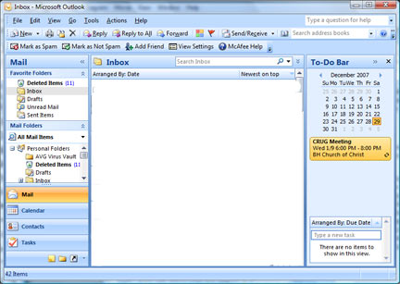

Although the Ribbon interface is not used in the main Outlook 2007 window it is used in sub or working windows. So when composing a new message or appointment you see a window with Ribbons.

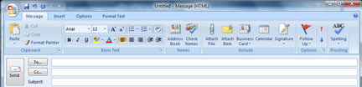
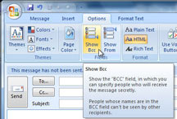

I use Bcc a lot so the message is sent to that recipient, but their name is not visible to other recipients. It is a nice practice to get into so that you are not spreading friends email addresses around to others. I would have liked the Bcc box to be visible in the default Outlook settings or at least a box to add Bcc. However it is not difficult to add. While creating a new message select the Options tab and in the Fields group click Show Bcc. This is also where you can select to show the From field if you want it to show when creating a message.

A useful new feature in Outlook 2007 is Instant search. Outlook uses the Windows Vista search technology so search results show as soon as they are found while the search is still running. Instant Search is available through a search box at the top of each Outlook task (Mail, Calendar, Tasks, Contacts, etc.). The Search utility is so quick and accurate that I might not have to create as many mail folders.

However, I doubt that my use of Outlook’s Folders or Categories will change. With Outlook 2007 it is still easy to create folders to organize email messages. I like to keep email sorted in separate folders. That way I can easily back up my critical email more frequently. I also use categories to organize my mail, calendar, contacts and tasks. Assigning contacts to categories makes it simpler to select recipients for a particular email. I generally like to individually select recipients for most of my email. However I still use email distribution lists occasionally.

Categories

The new Color Categories give a visual way to distinguish items from one another. I still prefer defining my own categories but appreciate the new color coding of each category. This makes it easy to locate information. Add the same category to email, calendar, and task items to easily locate all items in that category. The color coding makes it easy. To assign a category just select an item, right click it, point to Categorize and click the Category. When you need to find the information, you can search and sort by Category.

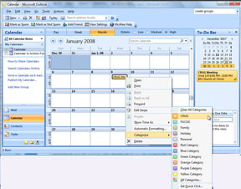.
Security

Even though Outlook 2007 contains junk email and phishing protection I still use a security application that scans my email for viruses, spam and phishing. However, the Outlook 2007 junk email filter sorts out most unwanted email and contains new protection against phishing. Messages caught by the junk email filter are moved to the Junk E-mail folder. So remember to review the messages in the folder occasionally to be sure that they are not legitimate messages. If they are, move them back to the Inbox by marking them as not junk or dragging them to any folder.

When you open or preview a message, the computer downloads the external content so any pictures can be displayed or the sound played. Junk email senders often use the downloading of external content to verify a email address as valid so they can add it to their spam list.

Another way Outlook protects you is by disabling links within email messages. You have the choice to approve them. Outlook also warns you from within the email message of potentially malicious sites. The default settings block links to external content like pictures or sounds, in HTML messages. The links are references to an external location on the Internet. When images and other suspicious content are prevented from loading you can choose to allow it. Just click the warning message at the top of the message to see options for downloading the attached pictures and managing other security settings.

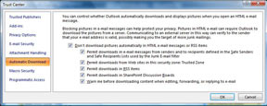
If you click Change Automatic Download Settings from a suspicious email message, the Trust Center opens so you can define which types of content to permit. The strictest settings are on by default. The Trust Center is also accessed from the Tools drop down menu. The Trust Center shows security and privacy settings for Office 2007 programs.

As another security precaution Outlook does not allow you to receive or send files of certain types as attachments. These types of files could potentially introduce a virus. This can be a problem if you want to send or receive a blocked file. When that is necessary change the file extension to one not blocked. Then add instructions in the message about renaming the file to the original file extension. Another option is to zip the files before attaching them.

Preview Attachments

Another neat addition in Outlook 2007 is the ability to preview attachments in the Reading pane right along with email text. If you subscribe to RSS feeds you can also read them within Outlook. To preview an attachment in a message without opening it, click it in the Reading Pane.

Conclusions

After a month of using Office 2007 I am very impressed with the suite of applications. I have not used all of the separate applications in depth but did open some of my files in each program. Converting to the new XML format or maintaining compatibility with Office 2003 was simple.

The new Ribbon interface in most of the Office 2007 applications is not only attractive but extremely user friendly. It provides an easy to understand grouping of commands in tabs. The graphic display of the commands provide for ease of use. Beyond the look of the new interface Office applications themes and styles make it a straightforward task to create attractive and professional looking documents. The new features allowing for quick preview of formatting changes before applying them is a superb tool. Now with a simple movement of the mouse you can see your file with an all new look.

Office 2007 offers improvements in computing security by easily allowing you to remove personal data from your documents prior to sharing them. Or use the Mark as Final command to make a document read only so others cannot modify it.

Another of the many improvements that I specifically want to mention is the ability to save documents from Office within applications to PDF. This feature is a true benefit to all users. Although I have PDF file generation applications on both of my computers it is still a time savings to create a PDF file right in Office. I was disappointed that I had to download an add on to get this capability.

I think that Office 2007 is a great suite of office applications and that with the various versions available it should be accessible to most.

This article has been provided to APCUG by the author solely for publication by APCUG member groups. All other uses require the permission of the author (see e-mail address above).

